**Measuring the Mass of Ruler by using Moments**

**11 /22 /2018**

**Ruiyan Maggie Huang**

**Physics 3**

**Maybe we should have abstract**

# Background and Introduction

### Theoretical background

When a force is applies to an object with a fixed point, the object will rotate around that fixed point known as pivot. The product of the magnitude of the force and its arm (the distance between pivot to the line of action of the force) is defined as moment.

The principle of moments state that a lever is balanced when the sum of clockwise moment equals the sum of anticlockwise moment, which can be expressed as:

$$F_{1}D_{1}=F_{2}D_{2}$$

In the formula, $F_{1}$ is the force acting on the lever with clockwise effect; $D_{1}$ is the distance from the pivot to the line of $F_{1}$; $F_{2}$ is the force acting on the lever with anticlockwise effect; $D_{2}$ is the distance from the pivot to the line of $F_{2}$;

Deriving from this formula, we can also get:

$$F_{2}=\frac{F_{1}D_{1}}{D_{2}}$$

Thus, knowing the value of the other three variables, we can calculate the value of $F_{1}$.

If we divide both sides of the equation by g the gravitational field, we get:

$$m_{2}g=\frac{m_{1}⋅g⋅D_{1}}{D_{2}}$$

$$m_{2}=\frac{m_{1}⋅D_{1}}{D_{2}}$$

### Objectives

The aim of this experiment is to measure the mass of a given ruler using the principle of moments, and then compare the experimental result with the theoretical value. We put the same mass on different positions of the ruler, and thus adjust the position of the pivot to keep the lever balanced.

We hypothesized that by changing the positions of the mass, in order to keep the equilibrium of the ruler, the pivot has to change accordingly. We will find the mass of the ruler using data derived from the position of mass and fulcrum.

# Materials and Methods

### Materials

A meter ruler, a set of 50g masses, a set of 10g masses, a binder clip, a paper clip, and an electronic scale.

### Procedure

1. Gather all the materials.
2. Put the two tails off the binder clip and bend the paper clip straight to a wire. Insert the wire vertically into one of the two holes between the binder clip and make sure it is fixed, so the reading will be easier and more precise.
3. Put the ruler on the binder clip, adjust until it balances, and record the precise position of the pivot, which should be around 50cm, and that is the position of the ruler’s center of mass.
4. Put the 10g mass (m1) on the 5cm mark of the ruler. Adjust the pivot until the ruler balances again. Record the position of the pivot.
5. Change the position of the mass in graduation of 5 cm a time until 40cm, and record each pivot respectively.
6. Change the mass to 50g, 100g, and repeat Step 5, respectively.
7. Measure the mass of the ruler using the electronic scale and compare the experimental result and the theoretical value.

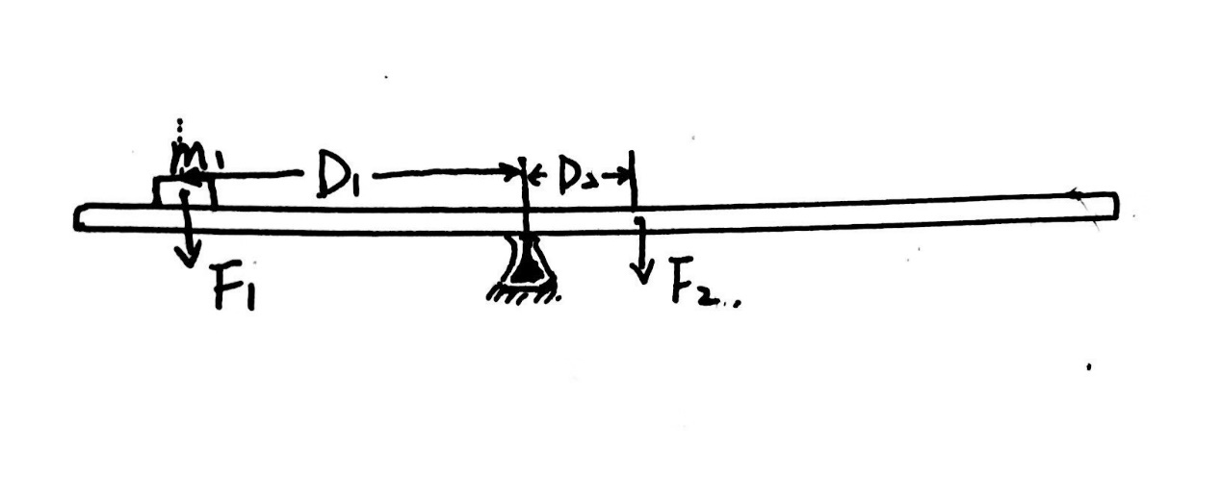

Figure 1. the apparatus

# Data and Calculations

### Raw data

|  |  |  |  |  |
| --- | --- | --- | --- | --- |
| **trials** | **m1 (g)** | **position of mass (cm)** | **position of pivot (cm)** | **Uncertainty (cm)** |
| 1 | 10 | 5.00 | 42.85 | 0.25 |
| 2 | 10 | 10.00 | 43.50 | 0.25 |
| 3 | 10 | 15.00 | 44.40 | 0.25 |
| 4 | 10 | 20.00 | 45.10 | 0.25 |
| 5 | 10 | 25.00 | 45.90 | 0.25 |
| 6 | 10 | 30.00 | 46.60 | 0.25 |
| 7 | 10 | 35.00 | 47.35 | 0.25 |
| 8 | 10 | 40.00 | 48.15 | 0.25 |
| 9 | 10 | 45.00 | 48.90 | 0.25 |

Table 1. the raw data from experiment 1

|  |  |  |  |  |
| --- | --- | --- | --- | --- |
| **trials** | **m1 (g)** | **position of mass (cm)** | **position of pivot (cm)** | **Uncertainty (cm)** |
| 1 | 50 | 5.00 | 28.30 | 0.25 |
| 2 | 50 | 10.00 | 31.25 | 0.25 |
| 3 | 50 | 15.00 | 33.50 | 0.25 |
| 4 | 50 | 20.00 | 35.50 | 0.25 |
| 5 | 50 | 25.00 | 37.90 | 0.25 |
| 6 | 50 | 30.00 | 40.25 | 0.25 |
| 7 | 50 | 35.00 | 42.60 | 0.25 |
| 8 | 50 | 40.00 | 45.00 | 0.25 |

Table 2. the raw data from experiment 2

|  |  |  |  |  |
| --- | --- | --- | --- | --- |
| **trails** | **m1 (g)** | **position of mass (cm)** | **position of pivot (cm)** | **Uncertainty (cm)** |
| 1 | 100 | 5.00 | 20.70 | 0.25 |
| 2 | 100 | 10.00 | 23.80 | 0.25 |
| 3 | 100 | 15.00 | 27.20 | 0.25 |
| 4 | 100 | 20.00 | 30.45 | 0.25 |
| 5 | 100 | 25.00 | 33.55 | 0.25 |
| 6 | 100 | 30.00 | 36.80 | 0.25 |
| 7 | 100 | 35.00 | 40.00 | 0.25 |
| 8 | 100 | 40.00 | 43.25 | 0.25 |

Table 3. the raw data from experiment 3

### Processed data

|  |  |  |  |  |
| --- | --- | --- | --- | --- |
| **trials** | **m1 (g)** | **D2 (cm)** | **D1 (cm)** | **uncertainty for ruler (cm)** |
| 1 | 10 | 7.30 | 37.85 | 0.50 |
| 2 | 10 | 6.65 | 33.50 | 0.50 |
| 3 | 10 | 5.75 | 29.40 | 0.50 |
| 4 | 10 | 5.05 | 25.10 | 0.50 |
| 5 | 10 | 4.25 | 20.90 | 0.50 |
| 6 | 10 | 3.55 | 16.60 | 0.50 |
| 7 | 10 | 2.80 | 12.35 | 0.50 |
| 8 | 10 | 2.00 | 8.15 | 0.50 |
| 9 | 10 | 1.25 | 3.90 | 0.50 |

Table 4. processed data from Experiment 1

|  |  |  |  |  |
| --- | --- | --- | --- | --- |
| **trials** | **m1 (g)** | **D2 (cm)** | **D1 (cm)** | **uncertainty for ruler (cm)** |
| 1 | 50 | 21.85 | 23.30 | 0.50 |
| 2 | 50 | 18.90 | 21.25 | 0.50 |
| 3 | 50 | 16.65 | 18.50 | 0.50 |
| 4 | 50 | 14.65 | 15.50 | 0.50 |
| 5 | 50 | 12.25 | 12.90 | 0.50 |
| 6 | 50 | 9.90 | 10.25 | 0.50 |
| 7 | 50 | 7.55 | 7.60 | 0.50 |
| 8 | 50 | 5.15 | 5.00 | 0.50 |

Table 5. processed data from Experiment 2

|  |  |  |  |  |
| --- | --- | --- | --- | --- |
| **trials** | **m1 (g)** | **D2 (cm)** | **D1 (cm)** | **uncertainty for ruler (cm)** |
| 1 | 100 | 29.45 | 15.70 | 0.50 |
| 2 | 100 | 26.35 | 13.80 | 0.50 |
| 3 | 100 | 22.95 | 12.20 | 0.50 |
| 4 | 100 | 19.70 | 10.45 | 0.50 |
| 5 | 100 | 16.60 | 8.55 | 0.50 |
| 6 | 100 | 13.35 | 6.80 | 0.50 |
| 7 | 100 | 10.15 | 5.00 | 0.50 |
| 8 | 100 | 6.90 | 3.25 | 0.50 |

Table 6. processed data from Experiment 3

Figure 2. The relationship between D1 and D2 for Experiment 1

By using the gradient and the mass to calculate, the mass of the ruler according to the data and graph from Experiment 1 is 55.84g.

Figure 3. The relationship between D1 and D2 for Experiment 2

By using the gradient and the mass to calculate, the mass of the ruler according to the data and graph from Experiment 2 is 56.86g.

Figure 4. The relationship between D1 and D2 for Experiment 3

By using the gradient and the mass to calculate, the mass of the ruler according to the data and graph from Experiment 3 is 55.12g.

The average of all the results from four experiment is 55.9 $±$ 0.9g, and by using electronic scale, the theoretical value of the ruler is 55.66 $±$ 0.01.

### Sample calculations

1. The arm (D1) for the force produced by the mass (m1)

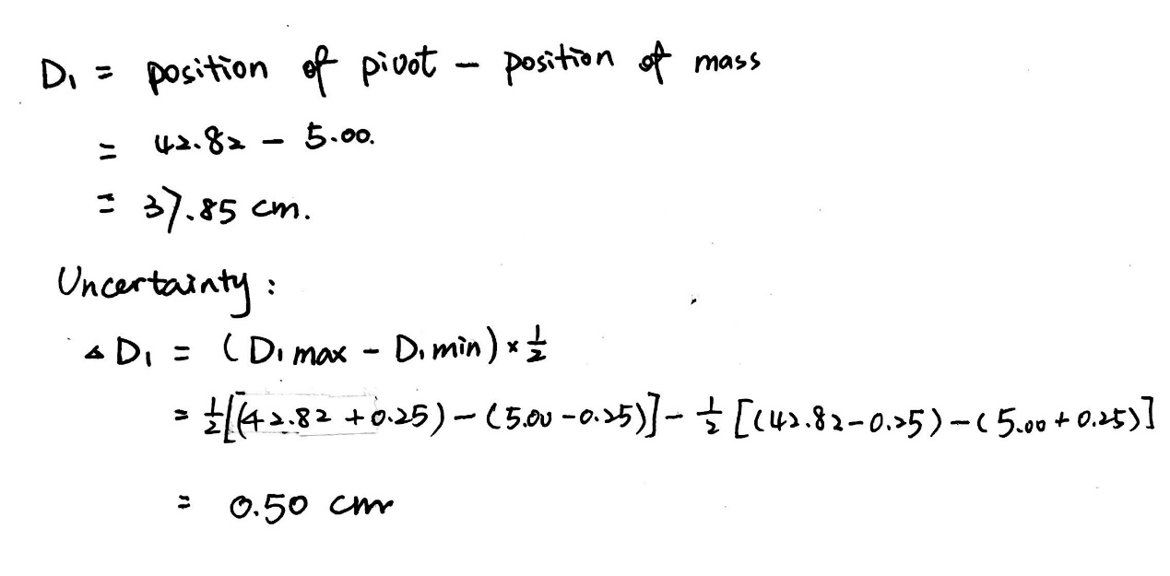

1. The arm (D2) for the weight of ruler:

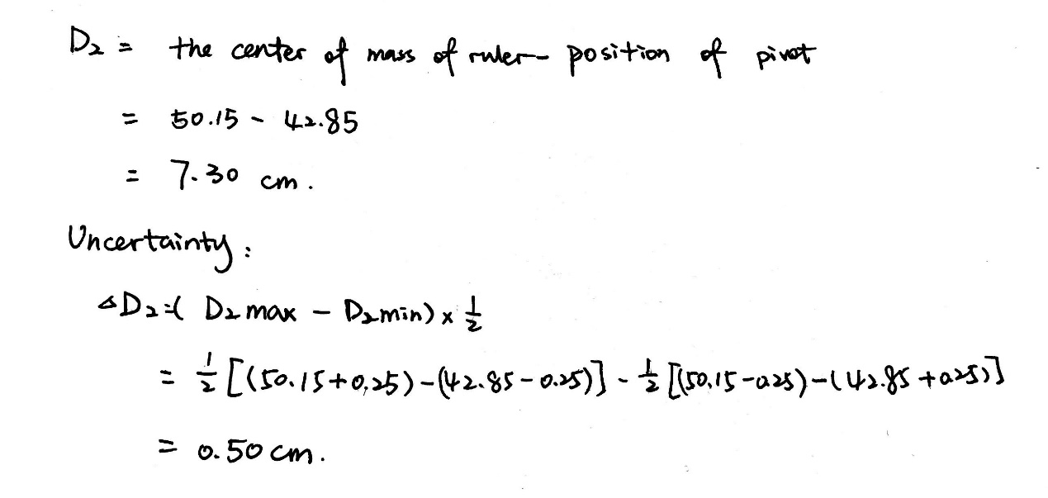

1. Using the principle of moments to find the mass of ruler:

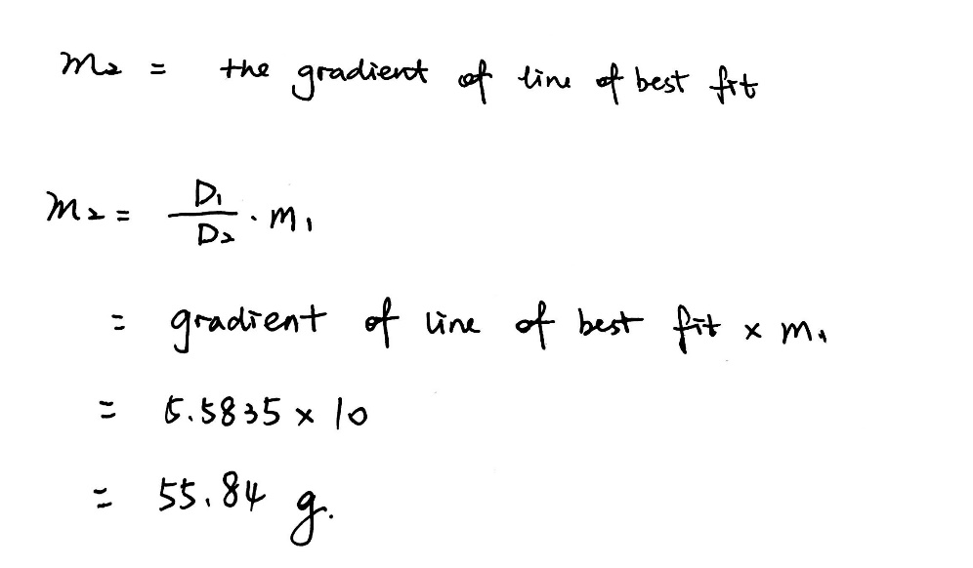

The reason for gradient rather than the mean.

Reasons for different masses

### Possible sources of error

The data is almost consistent with…

There are several possible reasons that causes those errors.

…

To minimize the errors that occurred in this experiment, there are several following ways:

# Results and Conclusions

### Results

The average of all the results from the four experiment is 55.9 $±$ 0.9g, and by using electronic scale, the theoretical value of the ruler is 55.66 $±$ 0.01.

### Discussion

Why using the wire?

Why using different masses and positions?

Why using the gradient of the graph?

Why…

Deriving from all the data collected, the final result is roughly 55.9 $±$ 0.9g. comparing with the theoretical value 55.66 $±$ 0.01, the percent error is thus:

So, the result is almost consistent with the theoretical value.

However, the discrepancy may be caused by the following sources:

### Discussion

1. Discussion begin with the purpose and summarize the basic idea of the experiment with…

wrong judgment of balancing the

beam and inaccurate measurement of the distances of the object to the axis of rotation. We

might say that the beam is already balance but maybe it is not really balanced totally. If the

beam is not balanced, it will affect our data since we applied the second condition of

equilibrium. For the measurement of the distances, since they are all measured manually,

there is a tendency to approximate the measurement since the objects we are measuring are

not stable.

and differences from the average mass in the hangers

# Conclusion

In this experiment, the aim was to …

It is hypothesized that…

After performing the experiment and doing several trails, the hypothesis got confirmed. Although the measured value of ... differed from the actual value by a few percent because of different sources of error, this difference was very small, leading to the conclusion that …

variables affect the time of the pendulum swing: length of string and angle measure. The mass, however, does not